**K.V.R Shinde shikshan sanstha’s**

**Shivraj College of Arts,Commerce and D.S.Kadam**

**Science college,Gadhinglaj.**(Dist.Kolhapur)

COMPUTER APPLICATION

**JOURNAL**

.NET TECHNOLOGY

S.Y[B.C.A]

2021-2022

NAME : Kusum Sayaji Patil.

CLASS : B.C.A-II

SEMISTER: 2nd

ROLL No:

GUIDANCE : Prof.P.B.patekari.

SIGN:

-:Assignment.1:-

Class = (B.C.A)2 Date =

Sub = .net technology

Q1. Write a console application program to implement conditional statement and looping statement.

A]. Accept 5 subject marks and calculate total marks, percentage and grade.

Solution:

using System;

using System.Collections.Generic;

using System.Linq;

using System.Text;

using System.Threading.Tasks;

namespace journal1_a

{

class Program

{

static void Main(string[] args)

{

int m1, m2, m3, m4, m5, tm;

double per;

Console.WriteLine("enter 5 sub marks");

m1 = Convert.ToInt16(Console.ReadLine());

m2 = Convert.ToInt16(Console.ReadLine());

m3 = Convert.ToInt16(Console.ReadLine());

m4 = Convert.ToInt16(Console.ReadLine());

m5 = Convert.ToInt16(Console.ReadLine());

tm = m1 + m2 + m3 + m4 + m5;

Console.WriteLine("total marks=" + tm);

per = tm / 5;

Console.WriteLine("percentage=" + per);

if (per >= 90)

{

Console.WriteLine("Dist");

}

else if (per >= 70)

{

Console.WriteLine("First Class");

}

else if (per >= 60)

{

Console.WriteLine("Second Class");

}

else if (per >= 35)

{

Console.WriteLine("Pass class");

}

else

{

Console.WriteLine("Fail");

}

Console.ReadLine();

}

}

}

Output:

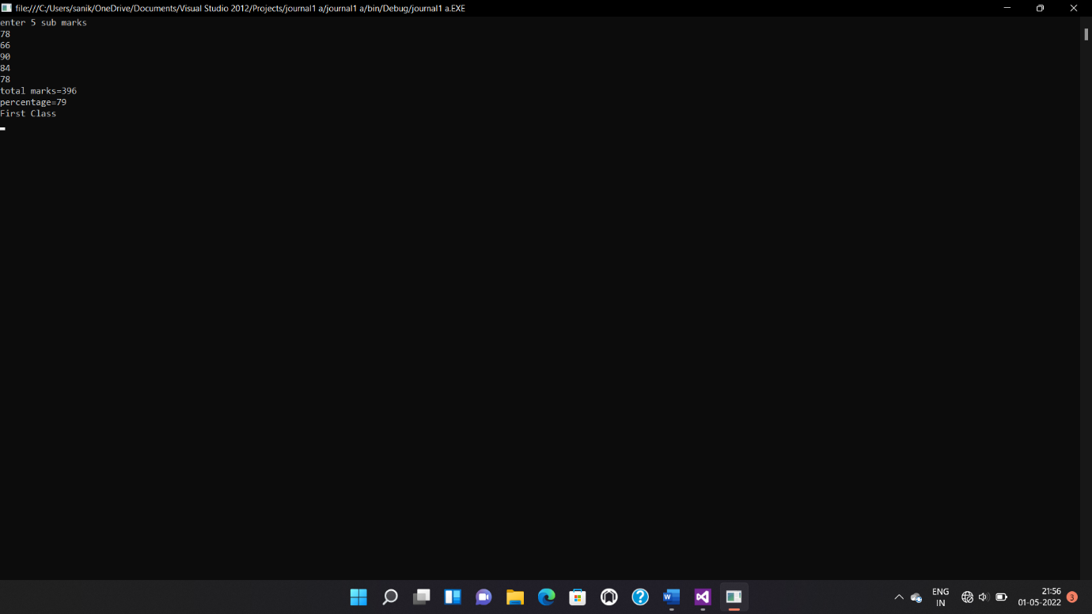

B]. To display given no is pallendrom or not.(using while)

Solution:

using System;

using System.Collections.Generic;

using System.Linq;

using System.Text;

using System.Threading.Tasks;

namespace journal1_b

{

class Program

{

static void Main(string[] args)

{

int no, rev = 0, dig, t;

Console.WriteLine("enter no");

no = Convert.ToInt16(Console.ReadLine());

t = no;

while (t > 0)

{

dig = t % 10;

rev =( rev * 10 )+ dig;

t = t / 10;

}

if (no ==rev)

{

Console.WriteLine("no is pallindron");

}

else

{

Console.WriteLine("no is not pallindron");

}

Console.ReadLine();

}

}

}

Output:

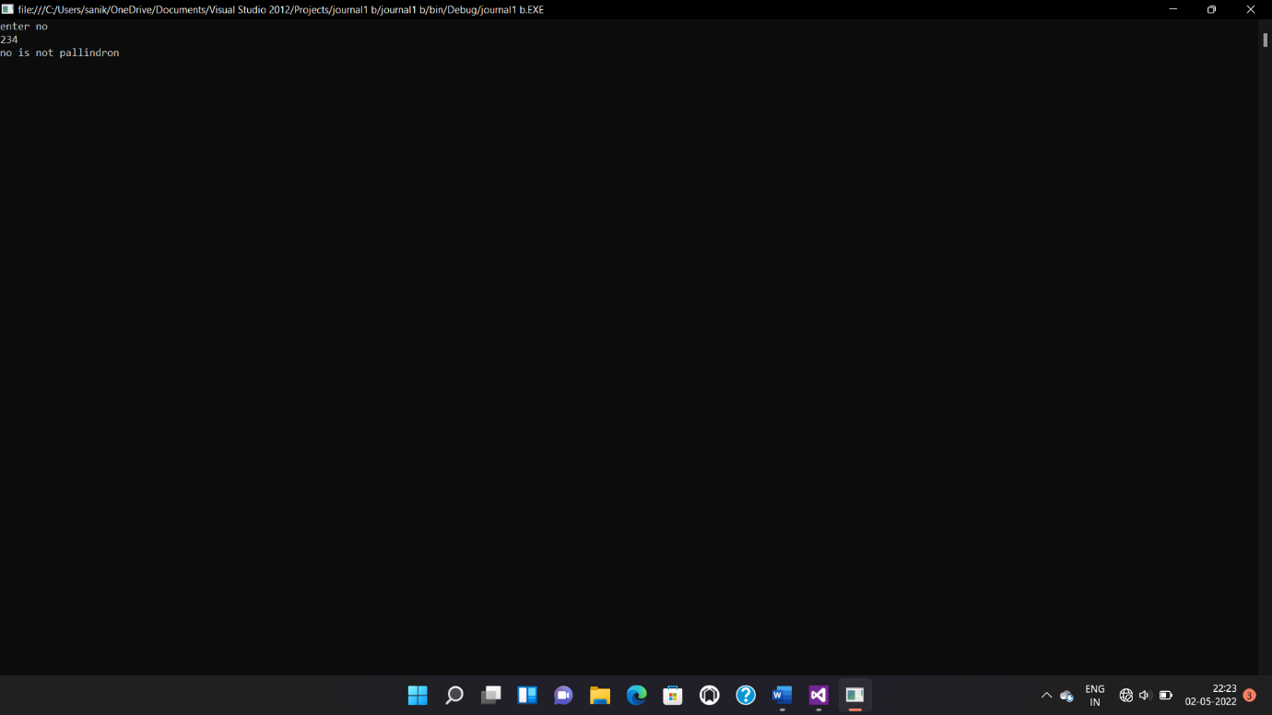

C] To display factorial of given number.

Solution:

using System;

using System.Collections.Generic;

using System.Linq;

using System.Text;

using System.Threading.Tasks;

namespace journal1_c

{

class Program

{

static void Main(string[] args)

{

int fact=1,no;

Console.WriteLine("enter no");

no = Convert.ToInt16(Console.ReadLine());

int i;

for (i = 1; i <= no; i++)

{

fact = fact * i;

}

Console.WriteLine("factorial=" + fact);

Console.ReadLine();

}

}

}

Output:

